ECE 49595 Senior Design Proposal

Team Member Names

Nathan Bitner: nsbitner@purdue.edu

Atin Dewan: dewan2@purdue.edu

Ishan Kumar: [kumar488@purdue.edu](mailto:kumar488@purdue.edu)

Name: YourPalate

Idea: Meal and Shopping Planner

Repository: <Github link>

Abstract

Meal planning and grocery shopping can be time-consuming and overwhelming tasks, particularly for college students and busy individuals. To address this challenge, for our ECE 49595O senior design project, we propose YourPalate, an open-source web application that automates the process of meal planning and shopping list creation. By utilizing machine learning algorithms, including graph neural networks (GNNs), and leveraging public APIs, YourPalate generates personalized weekly meal plans based on user preferences, dietary restrictions, culinary skills, and time constraints. Unlike traditional recipe platforms that focus on individual meals, YourPalate integrates user data to produce a balanced and diverse meal schedule that encourages culinary exploration while accommodating time and budget limitations. Additionally, the application offers a seamless user experience with features like ADA-compliant design, downloadable meal plans, and dynamically updated shopping lists. We will implement YourPalate using Django, TensorFlow GNN, and Neo4j as the primary technologies, demonstrating its potential as a valuable tool for enhancing dietary habits and simplifying meal preparation.

Introduction and System Features

In this project, we will develop a user-centric platform where individuals can input their dietary preferences, culinary skill levels, and weekly schedules. Based on this data, the system will generate a weekly meal plan that balances familiar dishes with new culinary challenges, tailored to the user's time constraints and dietary restrictions. Each recipe will either match the user’s stated comfort level or be selected by our predictive model to suit their preferences and abilities. An auto-generated shopping list will accompany the meal plan, which users can customize; any changes made will be immediately reflected in the meal plan. Users will also have the flexibility to replace or adjust meals, with corresponding updates to the shopping list. Both the meal plan and shopping list can be exported in formats like CSV or PDF for easy sharing and printing.

To begin using the program, the user inputs key information. This includes a general outline of their schedule, specifying how many meals they typically eat and how much prep time they prefer for each, ranging from minimal preparation to more than two hours. Next, the user selects several recipes they already enjoy and feel comfortable cooking. The user also provides dietary restrictions, such as veganism, religious observances, or personal preferences like disliking fish. Budgetary constraints are also considered, although the program focuses on the practical aspects rather than the reasons behind these choices. Another crucial piece of information is the user’s daily caloric intake goal, which is especially important if they are cooking for others, such as roommates or family. Finally, the user indicates how much they want to explore new recipes each week, both in terms of cooking skills and expanding their culinary palette. This data is stored in a file, such as a CSV or JSON, which the user can update and re-upload later. This allows users to gradually discover and incorporate new recipes into their preferences.

In addition to user inputs, the program considers several baseline considerations. While not specifically marketed as a fitness product, the meal plans will prioritize macronutrient breakdowns that align with government recommendations and ensure a regular inclusion of fruits and vegetables. Furthermore, perishable items, such as salad mixes, fruits, and certain vegetables, will be scheduled earlier in the week to prevent spoilage and reduce waste.

Use Cases

* Use Case 1: Learning to Cook
  + Users can specify their culinary skill and recipes that reflect their experiences will be given so they can become comfortable cooking and improve their abilities
* Use Case 2: Losing Weight
  + A restriction that a user can give is their calorie goals. Users will be given a meal plan that will help them attain their weekly goals to help them lose weight. They will be able to track the calories they eat on a daily basis to know if they are on track with their weight goals.
* Use Case 3: Saving time
  + Creating a meal plan by hand and creating a shopping list can take a large amount of time away. By automating the process users will save time from cooking each day and also planning their meals.

Requirements

* User will be able to input dietary restrictions, preselected recipes, time restrictions, and caloric needs onto hosted website
* User will be able to see and download meal plan and shopping list from hosted website
* User will be able to replace/adjust meals if they do not like the meal recommended
* API will pull data from our recipe websites upon request, filtering based on dietary, time, and caloric restrictions
* The website should successfully output meal recipes based on the users input requirements within 30 - 60 seconds.

System Context Diagram

Interaction with outside sources such as user and databases

Software Component Diagram

Includes above info and major project parts (like diagram we’ve got but less text)

System Diagrams

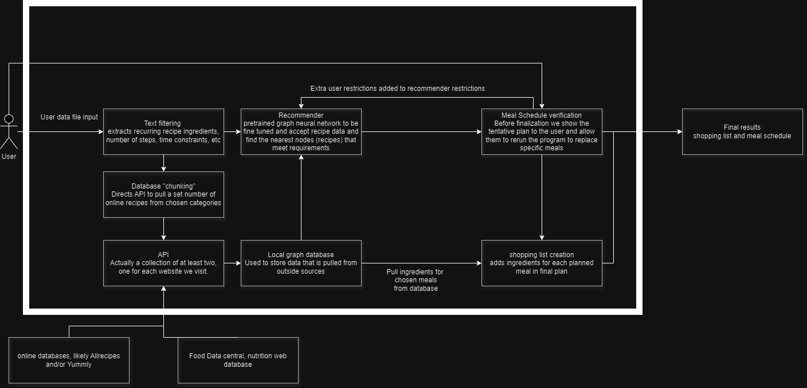

Open Source Libraries

* + **TensorFlow GNN or Pytorch Geometric**: Used to develop a recommender system, potentially utilizing a graph neural network (GNN) to find the most similar recipes that meet our requirements.
  + Here’s a Github repo associated with a paper using GNNs to recommend amazon products and movies. <https://github.com/Wenhui-Yu/LCFN>
  + This and several other similar pretrained GNNs are available on this repo <https://github.com/tsinghua-fib-lab/GNN-Recommender-Systems?tab=readme-ov-file#Ranking>, also published in conjunction with an academic paper
* **Django**: Very common high-level web framework, also includes REST API framework to pull our data with.
  + Food Data Central is a public website maintained by the US Department of Agriculture that provides nutrition data on huge amounts of common foods and recipes.
  + Public recipe-sharing websites or digital cookbooks are very common and can be used for estimating cooking difficulty, similarity to user skills, and prep time.
* **Scikit-Learn:** Useful for any machine-learning training and includes functions for data splitting and processing, though the bulk of our analysis may be too complex for many of their algorithms.
* **Python Pandas**: Essential for data handling and manipulation, enabling us to manage and analyze large datasets effectively.
* **Neo4j**: Graph based database management, Neo4j is preferable due to better graph traversal abilities.

Competitive Analysis

Lookup recipe radar sometime

A simple Google search for a recipe recommendation returns many web-based applications that claim to give new recipes to try based on available ingredients. Others aim to recommend new recipes based on your preferences.

AllRecipes and Yummly are popular platforms that offer a large number of recipes, but they serve their users differently. AllRecipes provides a community-based approach where users can search and filter through a large database of recipes submitted by users. It includes reviews and images from users, which help gauge the quality and appeal of recipes. It mainly focuses on individual recipes rather than personalized meal planning. Yummly takes a more personalized approach by offering recipe recommendations based on users’ dietary preferences, allergies, and favorite cuisines. It uses these inputs to filter recipes, making it easier for users to find a meal that suits their preferences. Yummly also focuses on individual recipes with more refined searching and filtering for users.

Contrastingly, our Meal Planner is designed to offer recipe suggestions and incorporate recipes into a meal plan for the week that can be adjusted to dietary restrictions, culinary skills, and time. Unlike AllRecipes which focuses on community-based recipes and lacks personalized meal scheduling or Yummly which personalizes recipes but does not incorporate meal planning, our planner automates the process of meal planning and grocery shopping. It supports customization, allowing users to update their preferences and schedules as needed. The goal is to automate the decisions and planning that go into creating a meal plan and following a balanced and healthy diet.

Our application differentiating factor: Our product is focused on removing some of the planning and research necessary to start at-home cooking. When creating a meal plan for our users, we include the skill level, time available, and user palette preferences. Our application will automate the decisions and planning that many people feel they are too busy or not knowledgeable enough to make. This will help them to form habits that can make them healthier and save money. We could remove worries of “what do I make for dinner?” or “what do I need from the store?” These thoughts every adult knows well. Our Meal and Shopping Planner offers value to students or busy individuals who want to enhance their dietary habits and culinary skills without overwhelming their schedules. Users may gradually improve their culinary skills and resort to home cooking as a viable option.